**LANE FOLLOWING MOBILE ROBOT**

**TEAM MEMBERS:**

Sandhya Yadav (A60)

Chinmay Bhoir(A23)

Mahendra Gudla(A25)

Suchita Boga(A57)

**Summary:**

The main purpose of the Lane Following Mobile Robot Navigation System Using Mono Camera is to achieve autonomous navigation of mobile robot, perception of surroundings, driving with planning and robot control algorithm are key features.

In this paper, introduced the implementation of Lane Detection System using Mono Camera.

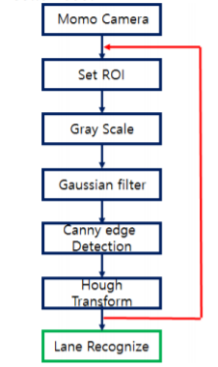

This is the proposed lane detection algorithm. First, for reducing computation complexity, we extract region of interest (ROI) in image data and remove useless data. As converting color image to gray scale image, we accomplish more efficiency in terms of computation, and Gaussian filter is applied for remove noise in image data. And in order to find edge data, we apply canny edge detection method, and hough transform is used for lane recognition.

For Obstacle Detection System of Mobile Robot, we will use Lidar sensor. Lidar (a.k.a Laser scanner) transmit light to obstacle and it calculate the distance between sensor to obstacle using light velocity and time of flight.

In this paper, a perception system for autonomous robot navigation system using mono camera and single lidar sensor. Mono camera can detect lane information with hough transform and lidar sensor can recognize obstacles information based on TOF information. By using two sensors, we can design the robot controller for following lane track.

**Reference:**

A Lane Following Mobile Robot Navigation System Using Mono Camera – 2017

Author: Yeongcheol Cho